1. 15% The following functions describe the oscillation of a circuit or a machine. Draw these functions on the same graph, for t=0 to t=10 in step of 0.1.
2. 15% Aircraft **A** flew east at a rate of 300 mi/hr and aircraft **B** flew south at a rate of 180 mi/hr. The position of the aircraft at 1 pm is shown in the following Figure.

Find the distance D between two airplanes as a function of time, from 1pm to 12pm in step of 0.5 hr and find the minimum value of D.

.

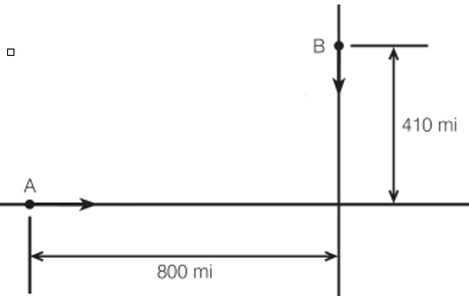

180 mi/hr

300 mi/hr

1. 27%



Use MATLAB to find the following:

1. Construct a matrix **B**，it is the transpose of A.
2. Construct a matrix **D,** deleting **3-nd row of A.**
3. Add a column with values 1 to the 1-nd column of D.
4. Extracting 1st and 3th column of A and put it into the matrix E.
5. Construct vector **x,** its elements is the only third row of **B**.
6. Calculate the sum of all the elements of **x.**
7. Pointwise multiplication of the 2-nd row of A and 3-th column of B.
8. Pointwise multiplication of the 1st row of A and 3-th column of B.
9. Find the maximum, minimum and summation values of the resulting vector in h.
10. 15% Write a MATLAB SUB-function to evaluate the members of the sequence, where a, and n are the inputs and the sequence value of is the output of this SUB-function and save it as a script file. Then, write a main function to input the range of the value n from 0 to 20, and =2, and call the SUB-function to evaluate the sequence value, and display the value of n and by using *fprintf*, as the following format:

n 

1. 1
2. 1
3. 4/6

1. 20% Suppose that a savings bank offers a tiered rate of interest that increases with the account balance as follows:

$$Interest Rate\left(balance\right)=\left\{\begin{aligned}8\%, &0≤balance≤5000 \\ 10\%, &5000<balance≤10000 \\ 15\%, &balance>10000\end{aligned}\right.$$

Suppose that a customer deposits 4000 for 20 years. Write a MATLAB script to compute the compound balance for years 1 through 20. Display the number of the years, the interest rate, the amount of interest, and the new balance. (Notes that: you must use for loop & if-else condition for the program)